Exploratory Data Analysis
of Palmer Penguins
  - Week 2 Report
Prepared by Mayank | 10 September 2026

Overview
This report explores a public dataset of 344 penguins using Pandas, Matplotlib and Seaborn. The analysis examines sample composition, body measurements, species and sex differences, correlations, unusual observations and annual summaries. The goal is to extract interpretable patterns while identifying where aggregation can mislead.
The clearest finding is that species matters: Gentoo penguins have the highest average body mass in this sample, and body mass is positively associated with flipper length. However, bill depth has a negative association with mass when species are pooled and a positive association within each species. This reversal is a central reason to examine groups before interpreting an overall correlation.

Research questions
- How are species represented across the sampled islands?
- How do body measurements vary, and how does mass differ by species and sex?
- Which measurement relationships persist within species?
- Do missing values or unusual observations materially change the descriptive conclusions?

Dataset and provenance
The Palmer Penguins dataset contains observations from three species and three islands in the Palmer Archipelago, Antarctica, collected during 2007–2009 by Kristen Gorman and the Palmer Station Long Term Ecological Research program. The simplified public dataset is distributed through the palmerpenguins project under CC0 [1, 2]. Each row is one sampled penguin record; the eight columns describe species, location, measurements, recorded sex and year.
The supplied CSV was obtained from the official project repository [3] on 10 September 2026. Direct download timed out, so all 345 lines, including the header, were recovered from the source’s line-numbered web representation in their original order. The packaged CSV preserves those field values; it is not claimed to be a byte-identical download. A SHA256 checksum is recorded in the notebook for reproducibility.

Scope
This is descriptive EDA of a historical sample. It does not estimate current penguin populations, establish causes, or train a prediction model. Eight figures and reproducible code accompany the findings.

1 Data structure and preparation
Variable | Meaning | Type or unit
species | Adelie, Chinstrap or Gentoo | Categorical
island | Biscoe, Dream or Torgersen | Categorical
bill_length_mm | Bill length | Numeric, mm
bill_depth_mm | Bill depth | Numeric, mm
flipper_length_mm | Flipper length | Numeric, mm
body_mass_g | Body mass | Numeric, g
sex | Recorded female or male | Categorical
year | Sampling year | 2007, 2008 or 2009

Initial inspection
df = pd.read_csv('data/penguins.csv', na_values=['NA'])
print(df.shape)
df.info()
print(df.isna().sum())
print(df.duplicated().sum())
The file contains 344 rows and 8 columns. There are no exact duplicate rows, unexpected category values or nonpositive observed body measurements. Two records lack all four measurements; sex is missing in 11 records. Each measurement therefore has 2 missing values (0.58%), while sex has 11 (3.20%). Species, island and year are complete. Exact-row checks cannot identify repeated individuals because this simplified file has no individual identifier.

Missing values and analysis populations
Analysis | Records used | Rule
Species and island counts | 344 | All records
Measurement plots and correlations | 342 | Observed measurements
Mass by species and sex | 333 | Observed sex and mass

Missing values are retained in the source, and each analysis excludes only rows missing its required variables. No mean, median or sex imputation is applied: replacement would add invented measurements and could shrink variation or distort associations. No global row deletion is needed. The 11 missing sex entries comprise 6 Adelie and 5 Gentoo records; Chinstrap has none.

Transformations and aggregation
Physical units are preserved and categories are not encoded as arbitrary numbers. Year is used only for grouping. Counts and percentages use all 344 records; mass means, medians and standard deviations use available mass values. Correlations use the 342 complete measurement records. IQR thresholds are calculated separately within each species. No scaling, log transformation or winsorization is needed for these descriptive questions.

2 Descriptive statistics and distributions
Measurement | Mean | Median | SD | Minimum | Maximum
Bill length mm | 43.92 | 44.45 | 5.46 | 32.10 | 59.60
Bill depth mm | 17.15 | 17.30 | 1.97 | 13.10 | 21.50
Flipper length mm | 200.92 | 197.00 | 14.06 | 172.00 | 231.00
Body mass g | 4201.75 | 4050.00 | 801.95 | 2700.00 | 6300.00

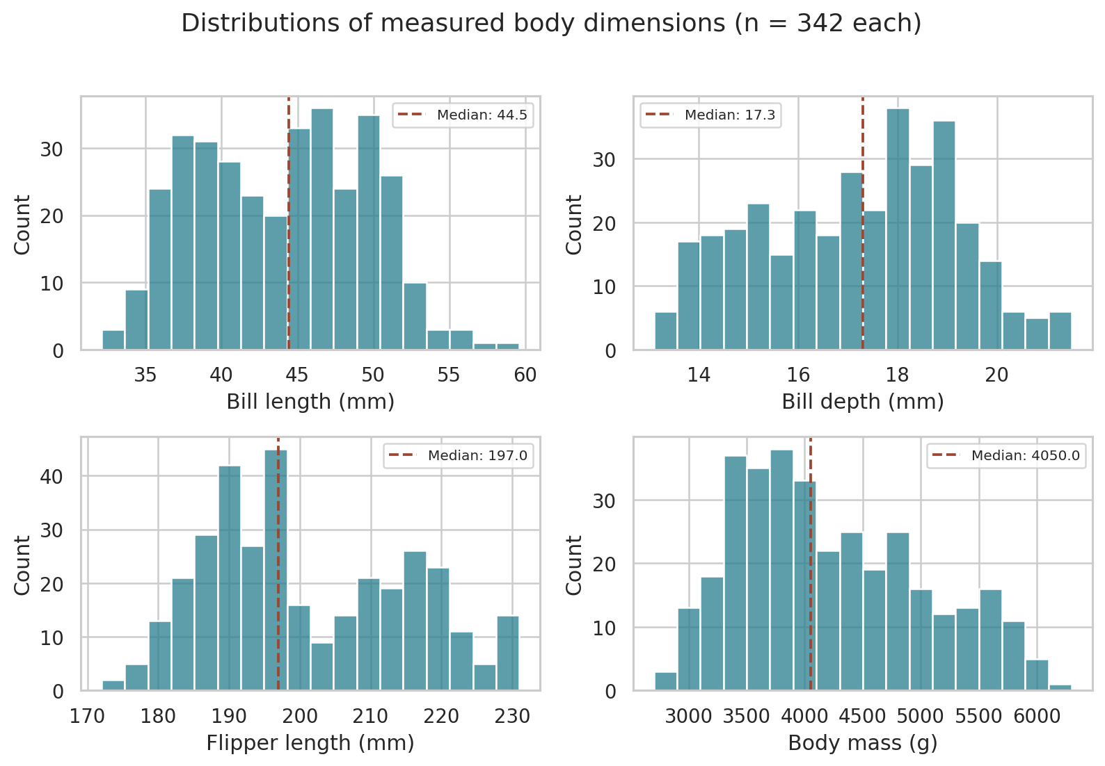
Figure 1. Histograms use 18 bins; dashed lines mark medians. Each panel uses 342 observations.
summary = df[NUM].describe().T
summary['IQR'] = summary['75%'] - summary['25%']
sns.histplot(data=df, x='body_mass_g', bins=18)
Body mass averages 4201.75 g, compared with a median of 4050 g, and spans 2700–6300 g. Its IQR is 1200 g. Flipper length has an IQR of 23 mm, and the histogram suggests more than one concentration of observations. These pooled distributions mix species of different sizes; their shapes should not be explained as a single homogeneous biological population.
The mean–median difference alone does not establish a particular distribution. Histogram shape depends on bin width, and valid biological variation can generate extreme observations. Group comparisons below help explain the pooled spread.

3 Sample composition and island structure
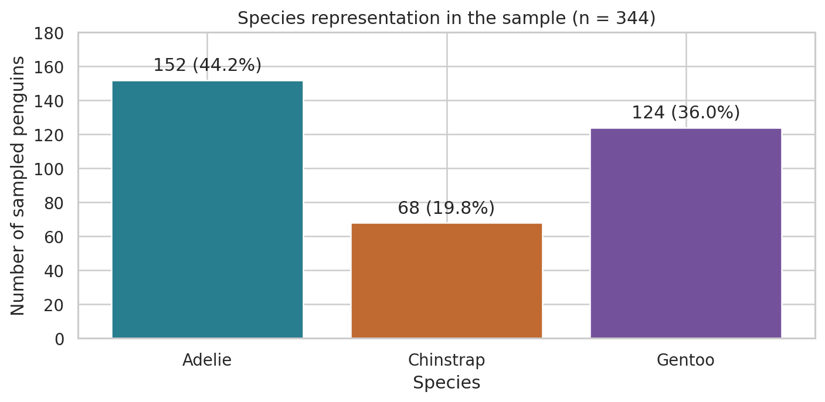
Figure 2. Species counts and percentages use all 344 records.
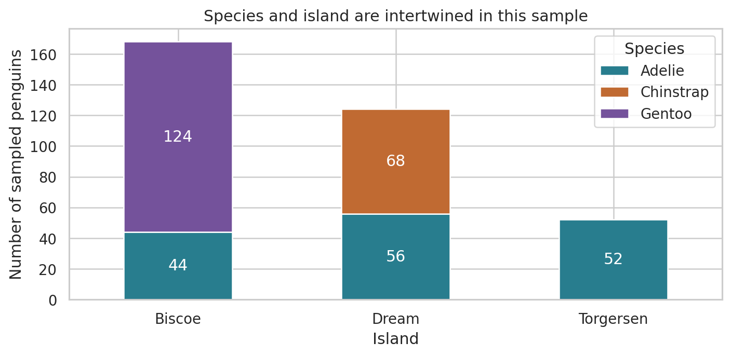
Figure 3. Stacked counts show which species were sampled on each island.
counts = df['species'].value_counts()
island = pd.crosstab(df['island'], df['species'])
Adelie contributes 152 records (44.2%), Gentoo 124 (36.0%) and Chinstrap 68 (19.8%). Biscoe contains 44 Adelie and 124 Gentoo records; Dream contains 56 Adelie and 68 Chinstrap; Torgersen contains 52 Adelie. Sample sizes are unequal and should accompany comparisons.
Gentoo appears only on Biscoe and Chinstrap only on Dream in this file. Island and species are therefore entangled. A higher island mean mass could reflect its species composition, rather than an island effect. These counts describe sampling, not ecological abundance or proof that unsampled species are absent from an island.

4 Body mass differences by species and sex
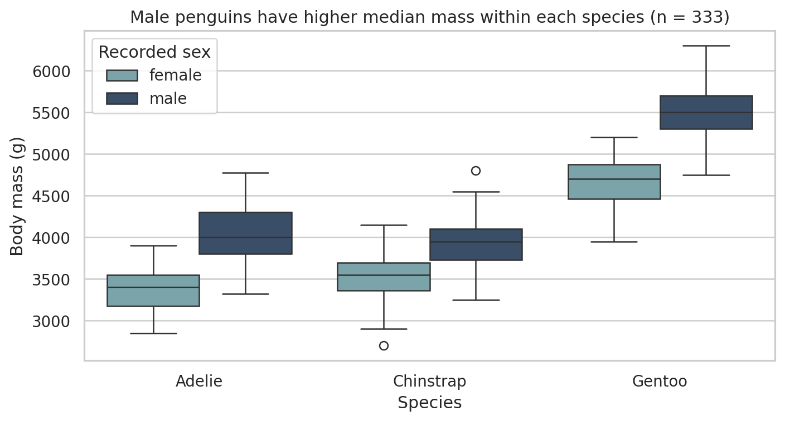
Figure 4. Boxes show quartiles and medians; whiskers extend to observations within 1.5 IQR. Separate markers flag extremes.
Species | Sex | n | Mean mass g | Median mass g
Adelie | female | 73 | 3368.8 | 3400
Adelie | male | 73 | 4043.5 | 4000
Chinstrap | female | 34 | 3527.2 | 3550
Chinstrap | male | 34 | 3939.0 | 3950
Gentoo | female | 58 | 4679.7 | 4700
Gentoo | male | 61 | 5484.8 | 5500

sex_data = df.dropna(subset=['sex', 'body_mass_g'])
sns.boxplot(data=sex_data, x='species', y='body_mass_g',
hue='sex', order=ORDER)
Mean mass is 3700.7 g for Adelie, 3733.1 g for Chinstrap and 5076.0 g for Gentoo when all available masses are used. Gentoo exceeds Adelie by about 1375.4 g (37.2%). Adelie and Chinstrap have similar average mass despite differing in other measurements.
Within each species, males have higher mean and median mass. The mean male–female gap is approximately 674.7 g for Adelie, 411.8 g for Chinstrap and 805.1 g for Gentoo. These observations are consistent with sex-related size differences, but the EDA does not establish their causes. Overlapping distributions also mean mass alone cannot perfectly identify sex or species.

5 Overall correlations
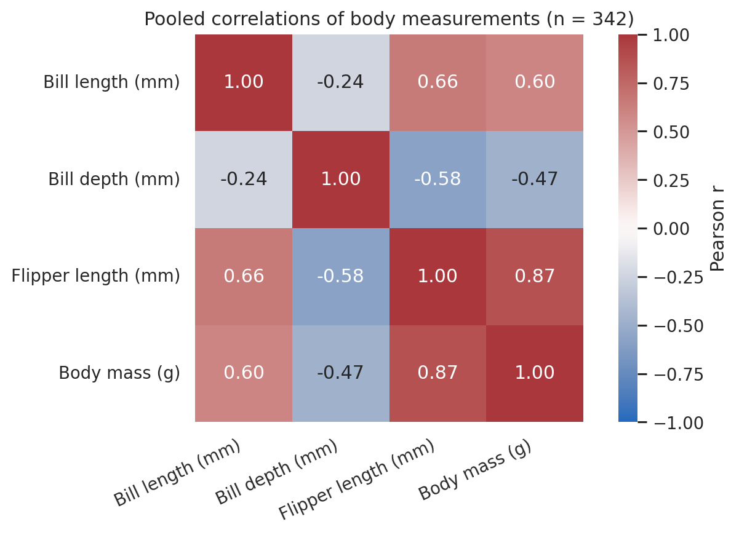
Figure 5. Pearson correlations range from −1 to +1; all pairs use the same 342 complete measurement records.
measurements = df.dropna(subset=NUM)
pearson = measurements[NUM].corr(method='pearson')
spearman = measurements[NUM].corr(method='spearman')
sns.heatmap(pearson, annot=True, vmin=-1, vmax=1,
center=0, cmap='vlag')
The strongest positive pooled relationship is between flipper length and body mass (Pearson r = 0.871). Bill length is also positively associated with flipper length and mass. Bill depth is negatively associated with mass in the pooled sample (r = −0.472). The next two sections check how grouping affects these findings.
Pearson correlation describes linear association, not a causal effect or a prediction accuracy. The coefficients depend on the sampled groups and ranges. Year and numeric encodings of species are excluded because their inclusion would invite misleading interpretations of measurement relationships.

Sensitivity to correlation method
The pooled flipper–mass Spearman correlation is 0.840, compared with Pearson 0.871. Both support a strong positive association, so the conclusion is not restricted to the exact linear scale. Agreement does not remove confounding or prove that unusual observations are harmless. Full Pearson and Spearman matrices are included in the supporting tables.

6 Flipper length and body mass within species
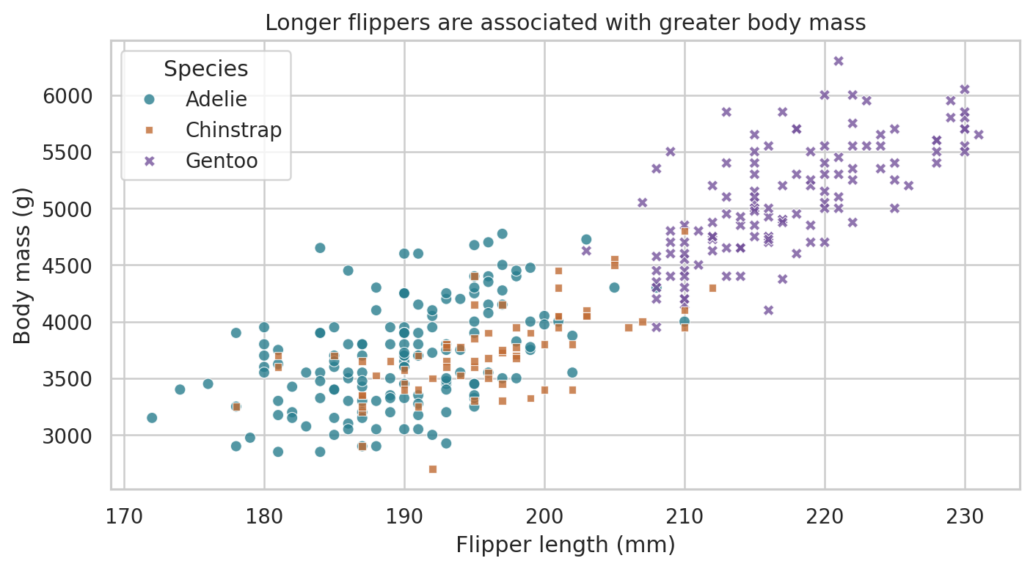
Figure 6. Colours and marker shapes distinguish species, revealing clusters hidden by the pooled coefficient.
Group | n | Pearson r | Spearman rho
Pooled | 342 | 0.871 | 0.840
Adelie | 151 | 0.468 | 0.475
Chinstrap | 68 | 0.642 | 0.670
Gentoo | 123 | 0.703 | 0.717

for species, group in measurements.groupby('species'):
r = group['flipper_length_mm'].corr(group['body_mass_g'])
print(species, len(group), r)
The positive flipper–mass association persists within each species, but all within-species coefficients are lower than the pooled value. Gentoo forms a visibly heavier, longer-flippered cluster. The pooled coefficient is strengthened by separation between species as well as variation within them.
A plausible interpretation is that larger birds tend to have both longer flippers and greater mass. Species and sex both influence the sampled size structure, so the scatterplot cannot show that increasing flipper length causes weight gain. For a future predictive model, species-aware evaluation and held-out data would be necessary; this EDA does not report model performance.

7 Why grouping changes the conclusion
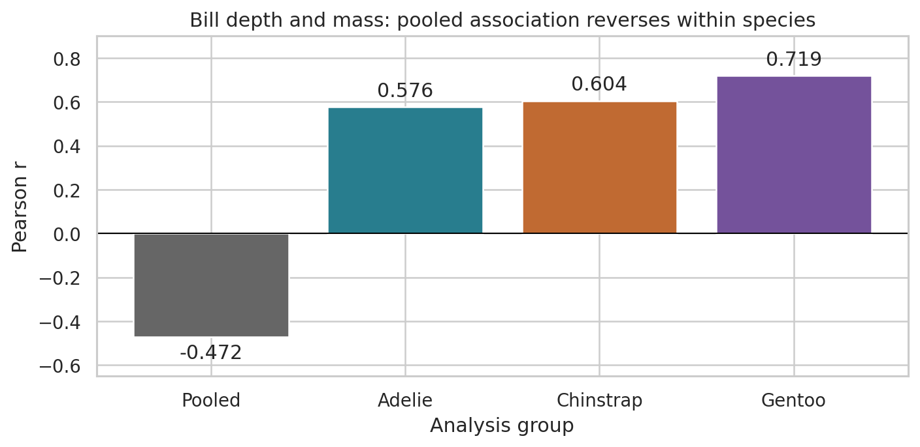
Figure 7. Bill-depth–mass Pearson correlations reverse sign when the sample is separated by species.
Pooled bill depth and body mass are negatively correlated (r = −0.472). Within Adelie, Chinstrap and Gentoo, the correlations are positive: 0.576, 0.604 and 0.719 respectively. This is an aggregation reversal: a relationship across mixed groups differs from the relationships within them.

Interpretation
Gentoo penguins are relatively heavy but have shallower bills than the other species. Pooling the species therefore produces a negative between-group pattern that overwhelms their positive within-group patterns. The correct conclusion is not that deeper bills generally imply lighter penguins. The relationship depends on which species are being compared.
pooled_r = measurements['bill_depth_mm'].corr(
measurements['body_mass_g'])
for species, group in measurements.groupby('species'):
within_r = group['bill_depth_mm'].corr(group['body_mass_g'])
print(species, within_r)

Why this matters for later analysis
A model or explanation based only on pooled correlation could select or reject variables for the wrong reason. Species should be considered explicitly, and potential sex effects should be examined before drawing biological conclusions. Stratification improves the description, but it does not eliminate every source of confounding or prove causality.
No formal significance tests are used here. The analysis focuses on direction, magnitude, sample size and visual structure; future confirmatory analysis would need clearly stated hypotheses and suitable uncertainty estimates.

8 Unusual observations and robustness
An outlier screen was applied to each of the four measurements within each species. Values below Q1 − 1.5 × IQR or above Q3 + 1.5 × IQR were flagged. Screening within species avoids judging every bird against a single mixed distribution. Six distinct records were flagged in at least one field.
Source row | Species | Flagged measurement | Value
20 | Adelie | Bill depth mm | 21.5
29 | Adelie | Flipper length mm | 172
130 | Adelie | Flipper length mm | 210
186 | Gentoo | Bill length mm | 59.6
314 | Chinstrap | Body mass g | 4800
315 | Chinstrap | Body mass g | 2700

Source row means the one-based data record number, excluding the header. The flag list and exact thresholds are saved in the supporting tables. The unusually long Gentoo bill and the two Chinstrap mass extremes merit checking against original field records, but an IQR rule alone cannot classify them as mistakes.
q1, q3 = group[col].quantile([0.25, 0.75])
iqr = q3 - q1
flag = (group[col] < q1 - 1.5 * iqr) | (
group[col] > q3 + 1.5 * iqr)

Sensitivity to excluding flagged records
Species | Original mean g | Without flags g | Change g
Adelie | 3700.66 | 3698.99 | -1.68
Chinstrap | 3733.09 | 3732.58 | -0.51
Gentoo | 5076.02 | 5068.03 | -7.98

For this diagnostic only, any record flagged in any measurement was temporarily excluded. The largest species mean-mass change was about 8.0 g for Gentoo, far smaller than the roughly 1375 g Gentoo–Adelie difference. The main species-mass conclusion is stable under this screen. This check concerns means only; it does not establish that every correlation is insensitive to the flagged records.

Decision
All flagged records remain in the main analysis because there is no supporting evidence of measurement or transcription errors. Deleting valid extremes would narrow the observed variation and could bias later analysis. IQR flags identify review candidates; they are not automatic deletion instructions.

9 Annual summaries and missingness sensitivity
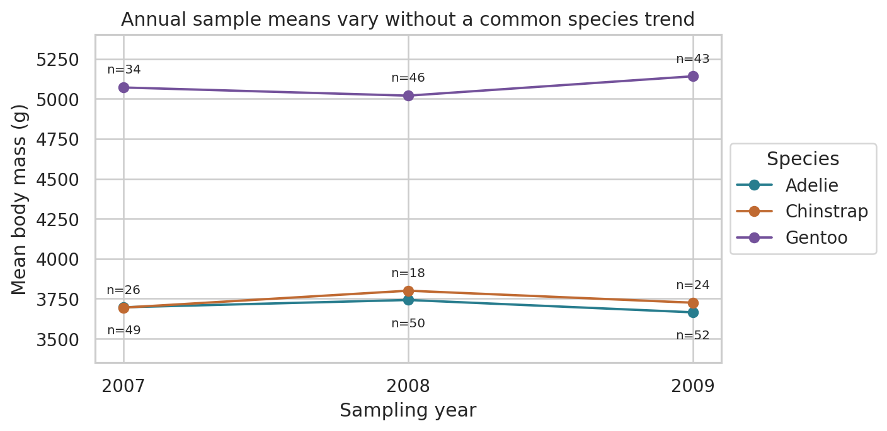
Figure 8. Points are species-specific annual means with valid mass counts. Connecting lines guide the eye; they do not track individual birds.
annual = df.groupby(['species', 'year'])['body_mass_g'].agg(
['count', 'mean', 'median'])
complete_means = df.dropna().groupby('species')['body_mass_g'].mean()
Gentoo remains the heaviest species in all three sampled years. The species do not follow a common directional pattern. With only three years and potentially different sampled birds, these summaries cannot establish growth trajectories, long-term population change or climate effects. No interpolation or forecasting is performed.

Effect of using only complete records
Species | Available mean g | Complete mean g | Change g
Adelie | 3700.66 | 3706.16 | 5.50
Chinstrap | 3733.09 | 3733.09 | 0.00
Gentoo | 5076.02 | 5092.44 | 16.42

Requiring complete records changes species means by 0–16.42 g. The observed mass ranking is therefore stable, but this does not show that missingness is random. Missing sex is concentrated in Adelie and Gentoo, and unobserved values cannot be validated from this simplified file. The main analysis uses available measurements to avoid losing usable observations unnecessarily.

10 Conclusions and reproducibility

Main findings
- Gentoo has the highest average body mass, while Adelie and Chinstrap have similar mass means. Male mass exceeds female mass within each species.
- Flipper length and mass are positively associated overall and within species. The stronger pooled coefficient partly reflects species separation.
- The bill-depth–mass correlation reverses sign after separating species, demonstrating the need to inspect grouped relationships.
- Island comparisons are entangled with species composition. Counts describe the sample rather than true abundance.
- Species mean-mass conclusions remain stable in the missingness and IQR sensitivity checks. Valid extreme values were retained.

Limitations and next steps
The dataset is a small historical observational sample from three islands and three years. Unequal representation, missing sex values and absent individual identifiers limit generalization. Diet, age and environmental variables are not included in this simplified file, so explanations involving them remain untested. A useful next step would be a species- and sex-adjusted analysis with uncertainty estimates and validation on additional observations. Nothing in this EDA establishes a causal relationship.

Reproducing the results
Extract Week2_EDA_Package.zip, open a terminal in Week2_EDA and run the commands below. The notebook contains the executed analysis cells, outputs and charts. The equivalent Python script recreates the eight figures and supporting tables. Data access is offline after extraction; installing dependencies may require internet access.
python -m pip install -r requirements.txt
python analysis.py
# Alternatively open Week2_EDA.ipynb in Jupyter and Run All
The report is a static submission document. The notebook and script reproduce the analytical results; they do not rebuild the Word formatting. README.md explains every deliverable. requirements.txt records the analysis package versions used. No machine-learning artifact is included because the assignment asks for EDA.

References
[1] Horst AM, Hill AP, Gorman KB. palmerpenguins data package (2020). Dataset documentation: https://allisonhorst.github.io/palmerpenguins/ . DOI: https://doi.org/10.5281/zenodo.3960218
[2] Gorman KB, Williams TD, Fraser WR (2014). Ecological Sexual Dimorphism and Environmental Variability within a Community of Antarctic Penguins. PLOS ONE 9(3), e90081. https://doi.org/10.1371/journal.pone.0090081
[3] Official source CSV: https://raw.githubusercontent.com/allisonhorst/palmerpenguins/main/inst/extdata/penguins.csv . Accessed 10 September 2026. Public dataset license: CC0.

